Mrs. Appel’s
Suggested School Supply List
*** Please ONLY label backpack. Do not put your child’s name on the supplies…..thanks.
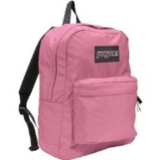
A large labled backpack
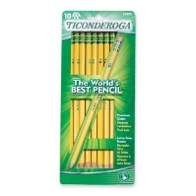
1 pack of #2pencils
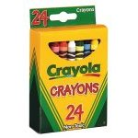
2 boxes of 24 count Crayola crayons
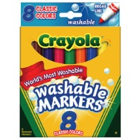
2 packs of Crayola washable markers
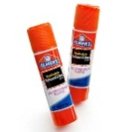
8 Elmers glue sticks
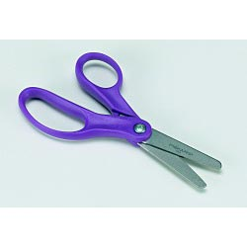
1 pair of Fiskars blunt tip scissors
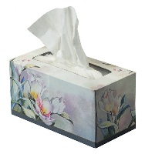
2 boxes of tissue (Kleenex, Puffs)
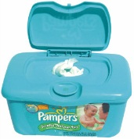
1 pack of baby wipes
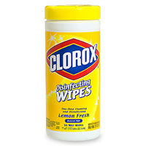
1 pack of disinfectant wipes
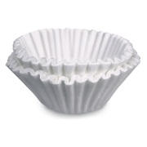
2 packages of coffee filters
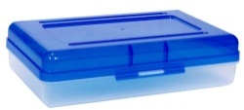
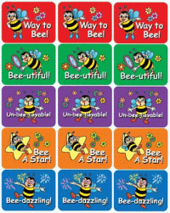
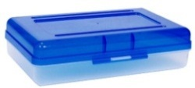
2 school supply boxes (one stays in homeroom)
1 pack of incentive stickers

$6.00 for a subscription to Weekly Reader

*** consider sending in a labeled change of clothes for your child. These can be helpful even if it’s just for a simple spill or slip in the mud!

